Solve the following problems with building user defined function in C:

1. Write a C program to calculate the sum of the following series (n will be taken from user):

$1+\frac{1}{1!}+\frac{3}{3!}+\frac{5}{5!}+….+\frac{n}{n!}$

1. Write a C program that can convert a decimal number to corresponding binary number.
2. Write a C program to get the multiplication result of first n prime numbers from 2 to a given range m. The input m will be taken from user.
3. Write a C program that will tell the user what an Armstrong Number is and the first n Armstrong Number in Number Line. (Input n will be taken from user)

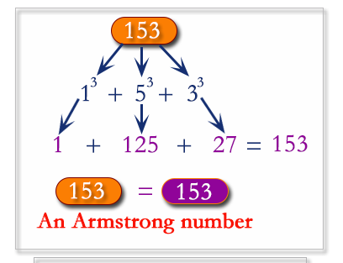

1. Write a C program that will tell the user what a Perfect Number is and will print the first n Perfect Number in Number Line (Input n will be taken from user).

